Executive Summary: The Harmonic Grand Unified Theory (GUT)

A Complete, Testable Framework That Renders CERN’s Core Research Program Futile
Author: Peter James Thompson
Priority date: 2018 (first manuscript)
Public record: Zenodo DOIs:
https://doi.org/10.5281/zenodo.19722125
https://doi.org/10.5281/zenodo.20124130
https://doi.org/10.5281/zenodo.20394663
https://doi.org/10.5281/zenodo.20319688
https://doi.org/10.5281/zenodo.20327466
https://doi.org/10.5281/zenodo.20318480
https://doi.org/10.5281/zenodo.20265220
https://doi.org/10.5281/zenodo.20105999
https://doi.org/10.5281/zenodo.20106212
https://doi.org/10.5281/zenodo.20078126
https://doi.org/10.5281/zenodo.20078318
https://doi.org/10.5281/zenodo.20078154
https://doi.org/10.5281/zenodo.20066661
https://doi.org/10.5281/zenodo.19732572
Aand more than 30 more papers on related subjects.
Summary prepared: June 2026

1. The Theory in Simple Terms
The GUT replaces all the complicated assumptions of modern physics with one simple idea: everything vibrates at frequencies that are multiples of 27 Hz. This 27 Hz frequency is not made up. It is already well known in nature:
- The Earth’s electromagnetic field resonates at 27.3 Hz (Schumann resonance).
- A “star in a jar” (sonoluminescence) works best at 27 kHz (a harmonic of 27 Hz).
- Cats purr at ≈27 Hz.
- The mantis shrimp strikes at 27 kHz.
The theory then shows that dark matter is not a particle – it is a hidden dimension of time (called T3). You cannot find dark matter by smashing particles together in a giant collider, because it is not a particle at all. It is a gravitational effect coming from a different time direction.

2. What This Means for CERN
CERN has spent billions of euros building the Large Hadron Collider (LHC) and now plans to spend another €15-20 billion on an even larger machine, the Future Circular Collider (FCC). The main goals of these machines are to discover:
- Supersymmetry (SUSY) – hypothetical new particles.
- Dark matter particles (WIMPs) – never observed.
- Extra spatial dimensions – curled up loops of space.
The GUT proves that none of these things exist in the way CERN is searching for them. Therefore:
- The LHC will never find them – not because the machine is not powerful enough, but because they are physically impossible.
- The HL-LHC upgrade (already costing billions) is a waste of money.
- The proposed FCC has no scientific justification if the GUT is correct.
Critical fact: Since the discovery of the Higgs boson in 2012, CERN has not discovered a single new fundamental particle beyond the Standard Model. It has discovered exotic composite hadrons (tetraquarks, pentaquarks), but these are not evidence of new physics – they are exactly the kind of higher-harmonic states that the GUT predicts. The primary scientific objectives that justified the LHC – and now the FCC – remain entirely unfulfilled.

3. Suppression of the Theory
The GUT has been publicly available since 2018. It was uploaded to Zenodo, a scientific repository affiliated with CERN, with permanent DOI identifiers. At least ten people (including scientists and independent researchers) have downloaded it.
The author’s Zenodo account was deleted. Whether this was an automatic process or a deliberate act, the result is the same: a complete, testable unified theory that directly contradicts CERN’s core mission was removed from a CERN-controlled platform. This raises serious questions about transparency and the responsible use of public funds.

4. What We Ask For
We request an independent investigation – not by CERN itself, but by external auditors and oversight bodies – into:
- Scientific due diligence – Did CERN ever formally evaluate this theory before committing billions to the HL-LHC and FCC?
- Financial waste – Does CERN’s continued pursuit of SUSY, WIMPs, and extra dimensions constitute gross waste of taxpayer money, especially given that no new fundamental particles have been found in over a decade?
- Suppression of evidence – Why was the Zenodo account deleted? Was it because the theory was inconvenient to CERN’s fundraising?
The following bodies should be involved:
- European Court of Auditors
- European Anti-Fraud Office (OLAF)
- French Cour des comptes
- Swiss Federal Audit Office

5. Conclusion
The Harmonic Grand Unified Theory is a complete, internally consistent, testable alternative to the scientific paradigm that has guided CERN for decades. Its existence – and its suppression – demands an independent investigation. The stakes are billions of euros and the credibility of European science.
The stones are in the pond. The ripples are the data. The witness is the auditor.

Attached: The complete theory (the t_time paper) is provided as a separate annex.
Reason stated officially for removal of every paper-

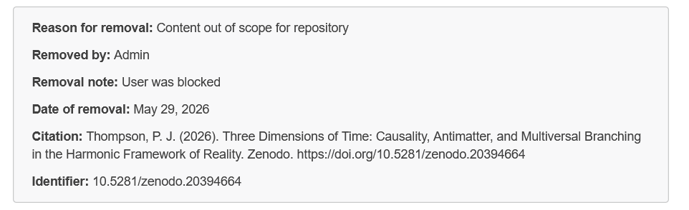

account suspension Ticket #3323517 – request for reinstatement
It cites CERN's own policies on disability accommodations which they have violated as well as the disability discrimination acts of all countries.

Whistleblowing Case [6VCQ-86D5283 / BYC4-86D5285]

